# Use Case Diagrams

## Current TRIUMF Inventory

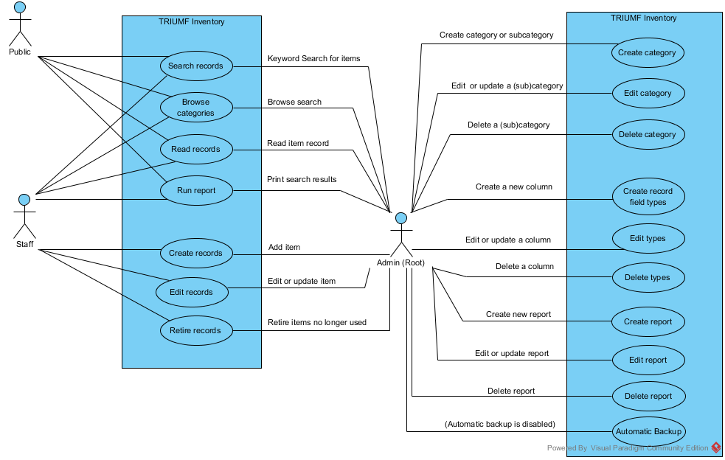

Figure .Use Case Diagram for TRIUMF inventory’s current system.

## Use Case Diagram for new inventory system.

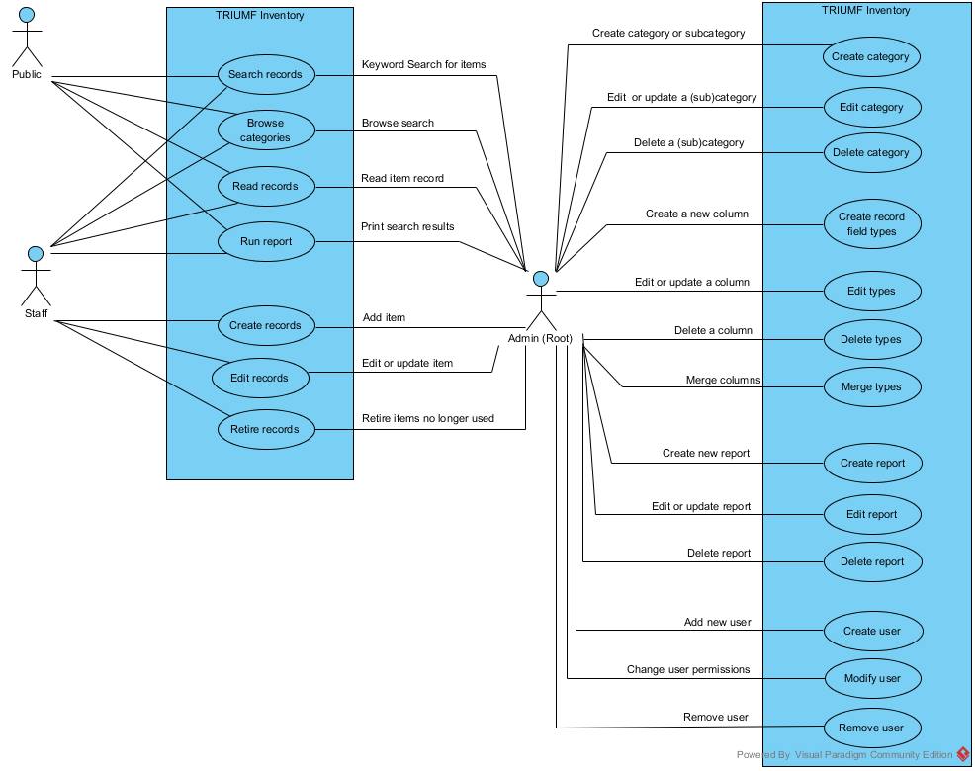

Figure .Use Case Diagram for TRIUMF inventory’s new system